1. Bot will enter the URL - https://publicaccess.merthyr.gov.uk/online-applications/

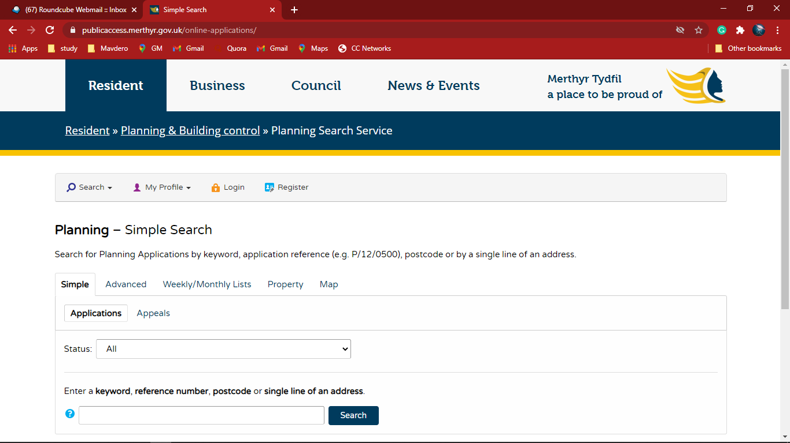

1. Bot will select “ALL” in Status Drop down manu

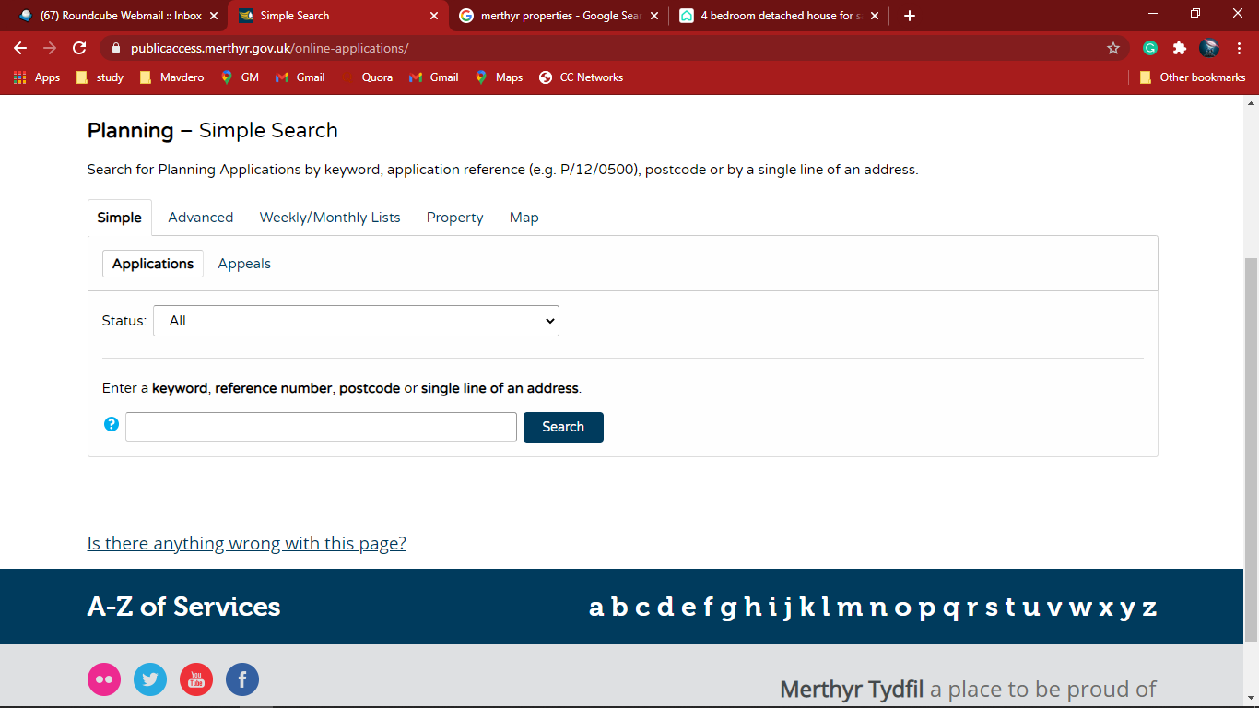

1. Bot will fill the Keyword, postal code or single line of address

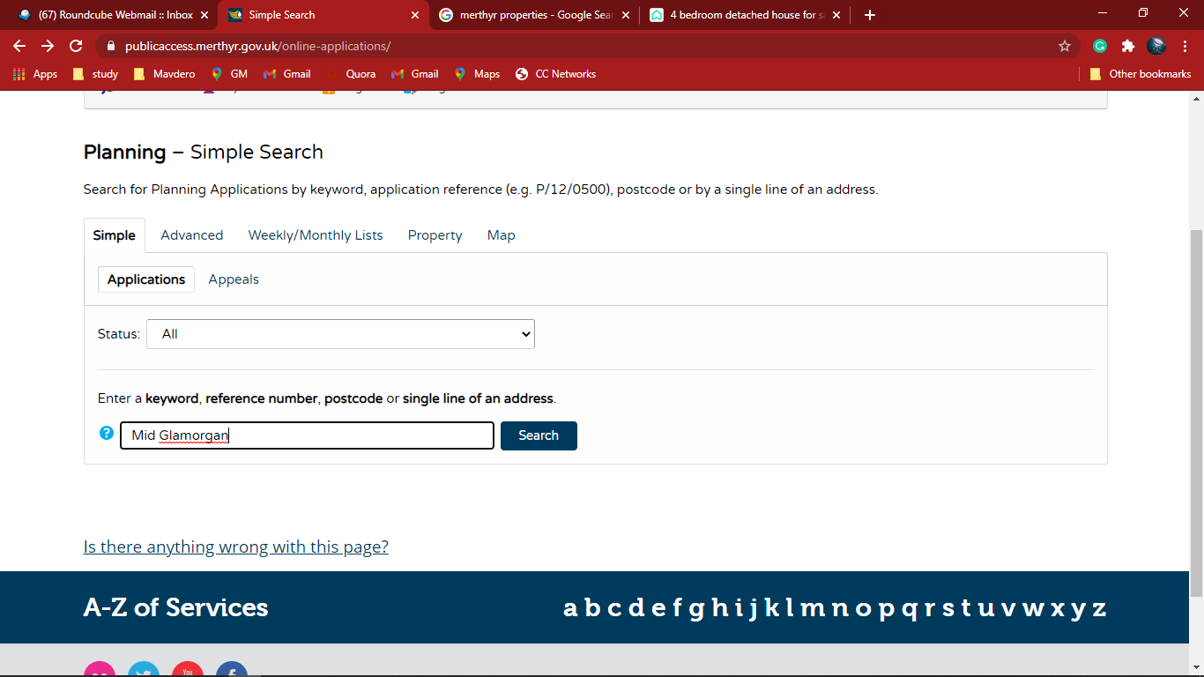

1. The Planning - Application Summary will show as follow

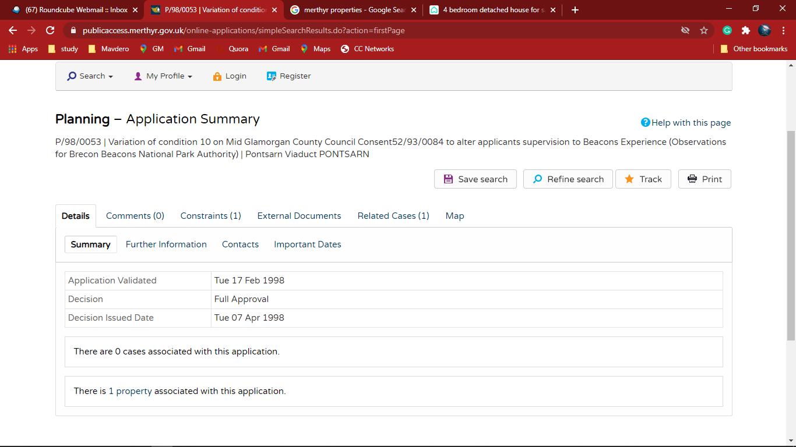

1. Bot will click and go to the Important dates

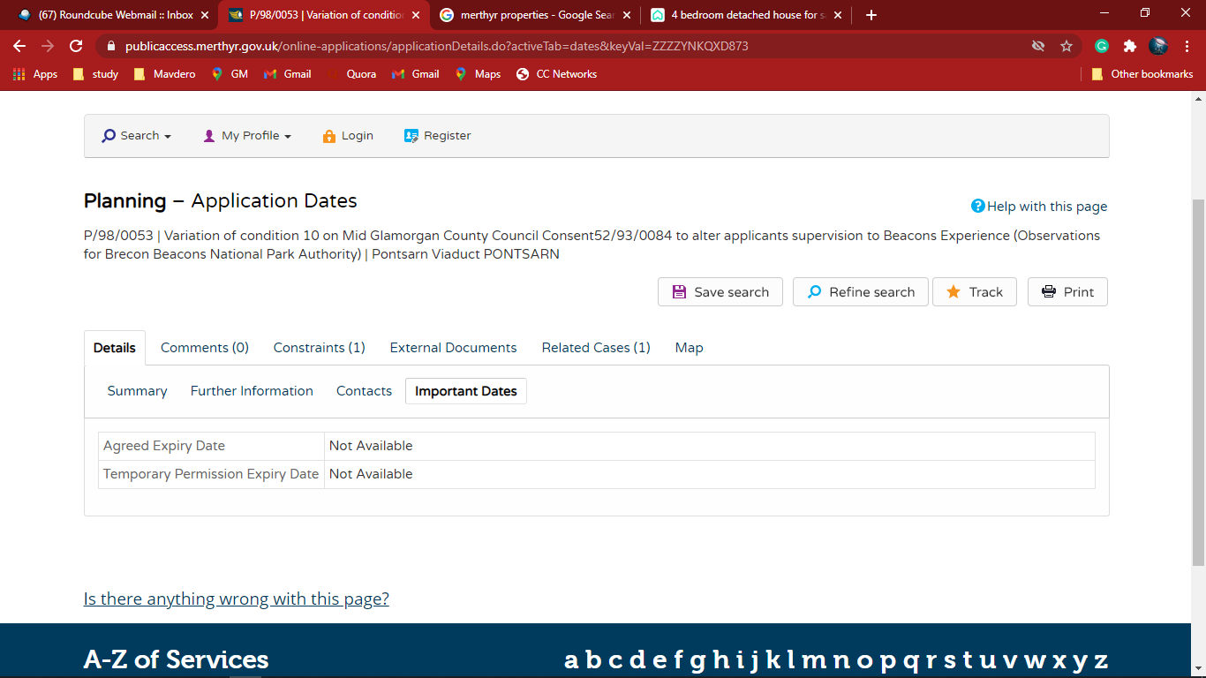

1. Bot will Extract the data from Important dates and populate in excel

